City Financial Statement Requirements

**Overview**

* As of **June 27, 2025**, per KRS 91A.040:
  + Any city with **population of** **less than 3,000** in the most recent federal decennial census, shall complete **a financial statement every even year and an audit every odd year**
    - Cities that meet thiscriteria can elect to submit an annual audit in place of a financial statement
  + Any city with **revenues and expenditures less than $500,000**, and no long-term debt, shall complete **a financial statement annually**
    - Cities that meet thiscriteria can elect to submit an annual audit in place of a financial statement
  + Any city with **population over 3,000 with** **revenues and expenditures over $500,000** shall complete **an audit annually**
* The **release of MRA** is tied to submission of the Audit, Financial Statement and Uniform Financial Information Report (UFIR)
* All submissions must be sent **ELECTRONICALLY** to [DLG-CSD@ky.gov](mailto:DLG-CSD@ky.gov)
* **Failure to submit** the Audit, Financial Statement and UFIR shall cause the Department for Local Government (DLG) to **withhold Municipal Road Aid (MRA)**, and notify all state agencies that provide funding and services to the city to suspend or delay each until compliance is met

**Financial Statement Opt Out**

* Cities that choose to submit an audit in place of a financial statement should complete and submit the **Financial Statement Opt Out form** to DLG prior to the financial statement October 1 due date to avoid having MRA funds withheld
* Email [DLG-CSD@ky.gov](mailto:DLG-CSD@ky.gov) to request the form

**Extension Request**

* When **extenuating circumstances** prevent a city from completing and submitting their audit or financial statement by the applicable deadlines, the city should submit the **City Extension Request form** to DLG to request an extension to on or before the applicable deadlines
* DLG determines that the request is warranted by extenuating circumstances beyond the city’s control
* Email [DLG-CSD@ky.gov](mailto:DLG-CSD@ky.gov) to request the form

***This document is for informational purposes only and should not be submitted to DLG.***

**Financial Statement**

**Requirements**

* **Due October 1**
* Must be electronically sent to DLG; email to **DLG-CSD@ky.gov**
* **Does not have to be completed by a certified public accountant (CPA)**
* An elected city employee, such as the Mayor or Clerk, can create the Financial Statement using a computer or accounting program, such as Excel or QuickBooks
* There is no specific form that needs to be completed
* Per KRS 424.220, all of the following must be included in the Financial Statement:
  + The total amount of funds collected and received during the fiscal year from each individual source; and
  + The total amount of funds disbursed during the fiscal year to each individual payee of greater than $1,000; and
  + The total amount of funds paid to each elected official as salary or commission; and
  + The amount of salaries paid to all nonelected county employees shall be shown as lump-sum expenditures by category, such as road departments, jails, solid waste, etc.; and
  + A **bank certificate** from the cashier or other proper officer of the banks in which the funds are or have been deposited during the past year, showing the balance, if any, of funds; and
  + A **sworn statement** signed by the city officer whose duty it is to collect, receive, and/or have custody of the funds collected from the public, which states that the itemized financial statement is an accurate reflection of the funds collected, received, held, or disbursed by him during the fiscal year just closed

**Example**

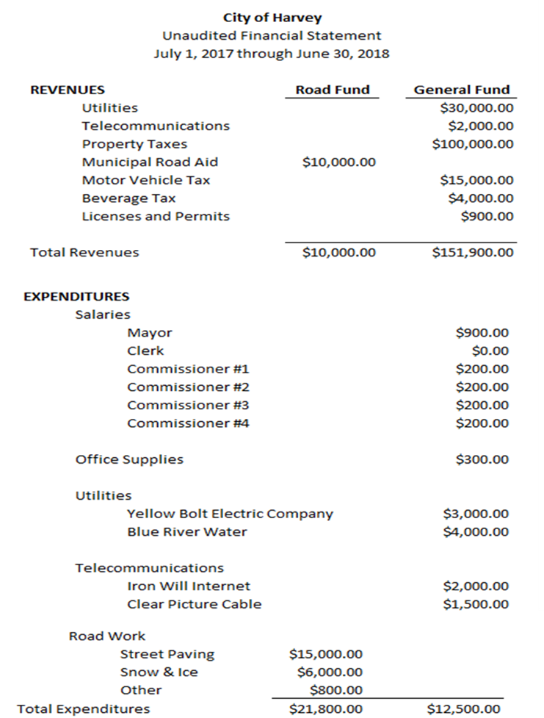

**Bank Certificate**

**Requirements**

* Should be printed on the bank’s letterhead.
* Should include the bank balance for each of the city’s funds as of June 30, close of fiscal year which the Financial Statement covers with a hand written or typed statement.
  + Example Statement: “Bank Balance of $500,000 as of June 30, 2018.”
* Must be signed by the cashier or other officer of the bank.
* Does not need to be notarized.

**Example**

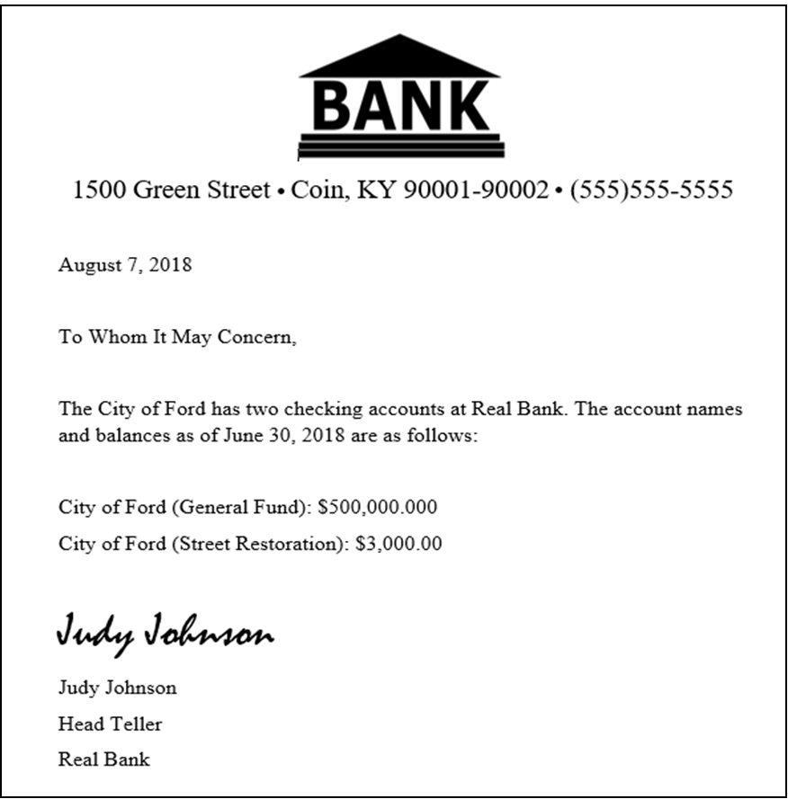

**Sworn Statement**

**Requirements**

* Should be printed on the city’s letterhead.
* States that the itemized financial statement is an accurate reflection of the funds collected, received, held, or disbursed by the city officer during the fiscal year just closed.
* Must be signed by the city officer whose duty it is to collect or have custody of the funds collected from the public.

**Example**

